SHREYA PANCHAL
Assignment-6: Introduction to cloud Networking Virtual Private Cloud(VPC) basics and components. Create a basics VPC on AWS with a Public and private subnet.
1. Log in to your AWS account, open the VPC dashboard, and create a new VPC named InstaVibeVPC with a custom IPv4 CIDR block (e.g., 10.0.0.0/16).
Answer: Create a VPC
Steps:
- Login to AWS Console.
- Search VPC.
- Click Create VPC.
- Select VPC only.
- Name: InstaVibeVPC
- IPv4 CIDR: 10.0.0.0/16
- Click Create VPC.
Created a VPC named InstaVibeVPC with IPv4 CIDR block 10.0.0.0/16.
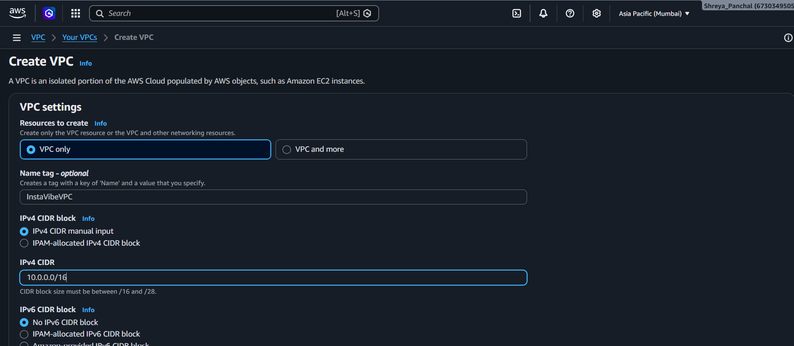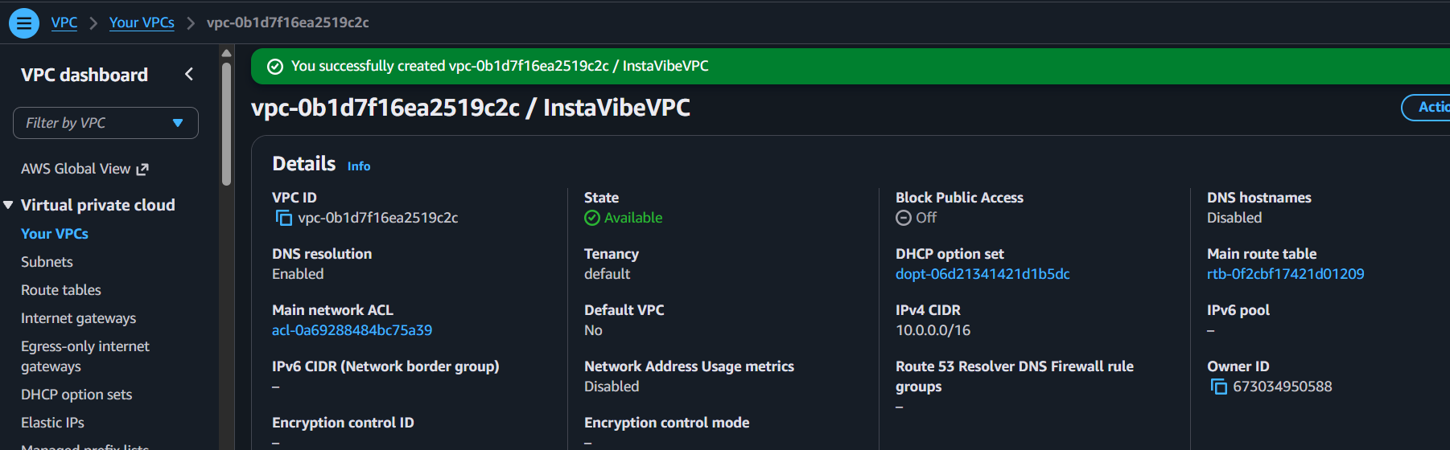
2. Inside your InstaVibeVPC, create two subnets: one public subnet (e.g., 10.0.1.0/24) for hosting a web server and one private subnet (e.g., 10.0.2.0/24) for backend services.<br><br><em><strong>Hint:</strong> Name your subnets as 'PublicSubnet-Zomato' and 'PrivateSubnet-Zomato' for clarity.</em>
Answer: Created two subnets inside InstaVibeVPC:
- PublicSubnet-Zomato with CIDR block 10.0.1.0/24 for hosting the web server.
- PrivateSubnet-Zomato with CIDR block 10.0.2.0/24 for backend services and databases.
Both subnets were successfully created in the same VPC.
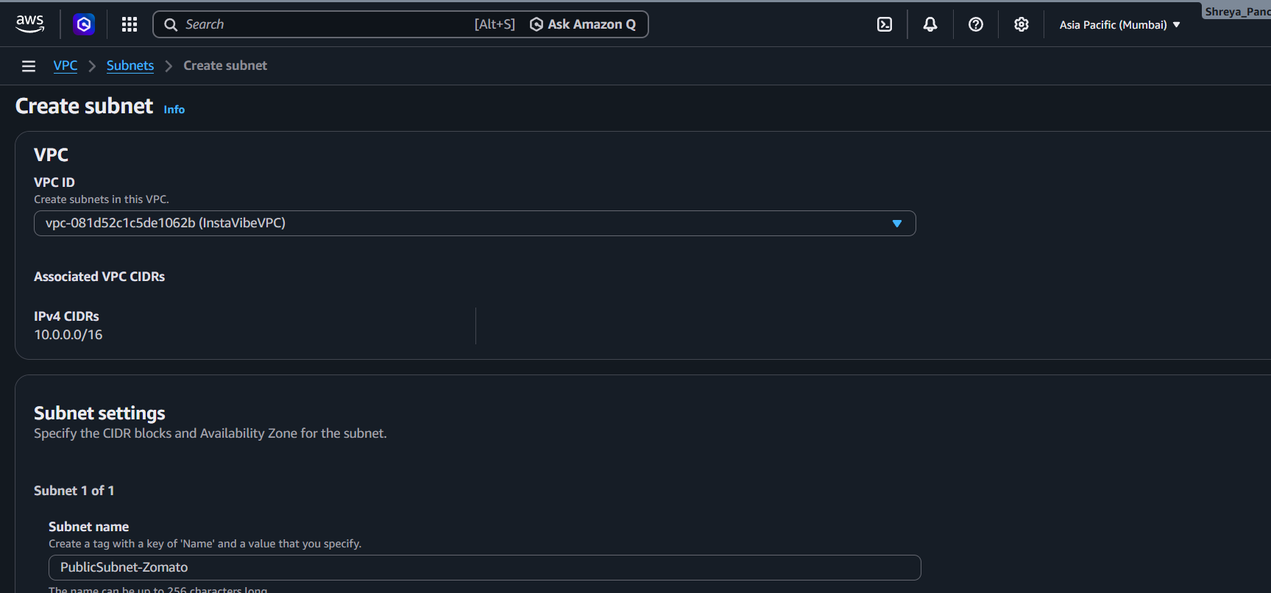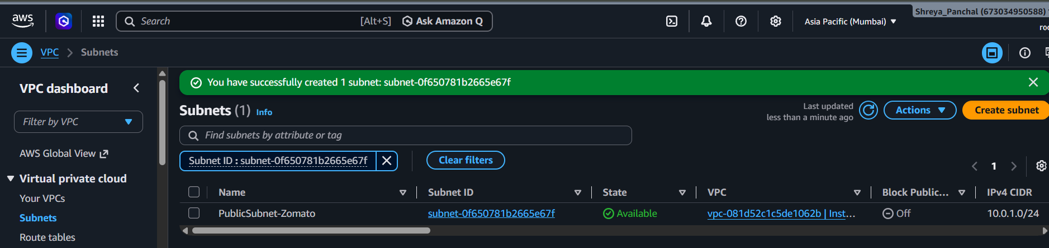
3. Configure an Internet Gateway and attach it to your InstaVibeVPC so that only the public subnet can access the internet, while the private subnet cannot.
Answer:
- Created an Internet Gateway named InstaVibe-IGW.
- Attached the Internet Gateway to InstaVibeVPC.
- This configuration allows resources in the Public Subnet to communicate with the internet.
- The Private Subnet does not have direct internet access because it is not routed to the Internet Gateway.
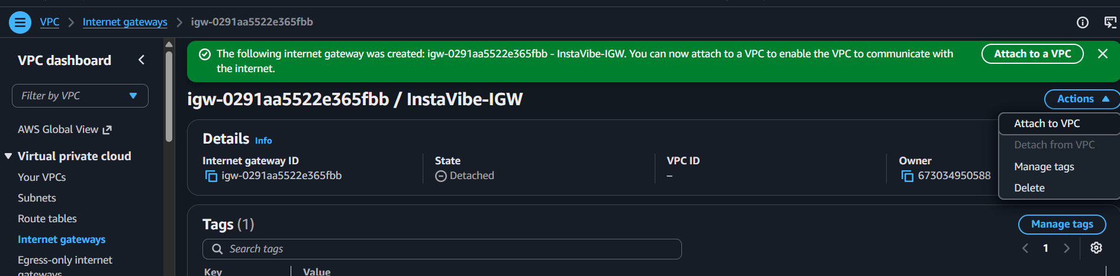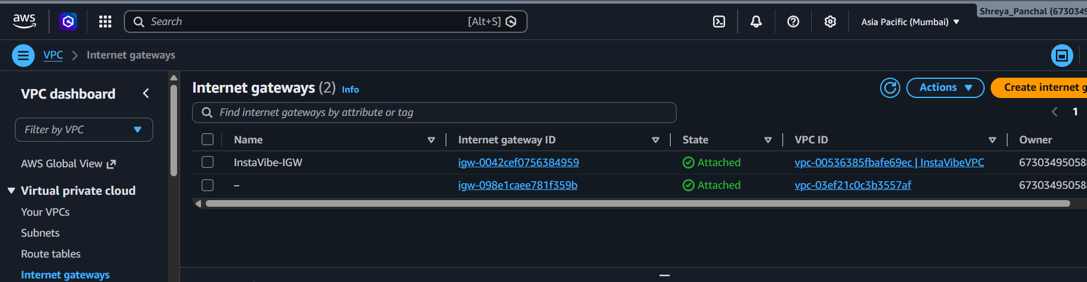
4. Set up route tables so that your public subnet routes traffic to the Internet Gateway, but your private subnet does not. Verify this by checking the route table associations.
Answer:
- Created a Public Route Table (Public-RT) in InstaVibeVPC.
- Added the route 0.0.0.0/0 and configured it to use InstaVibe-IGW (Internet Gateway).
- Associated PublicSubnet-Zomato with Public-RT to enable internet access.
- Created a Private Route Table (Private-RT) and associated it with PrivateSubnet-Zomato.
- The private route table contains only the local route, so it does not have direct internet access.
Result:
- PublicSubnet-Zomato can communicate with the internet through the Internet Gateway.
- PrivateSubnet-Zomato remains isolated from direct internet access, improving security.
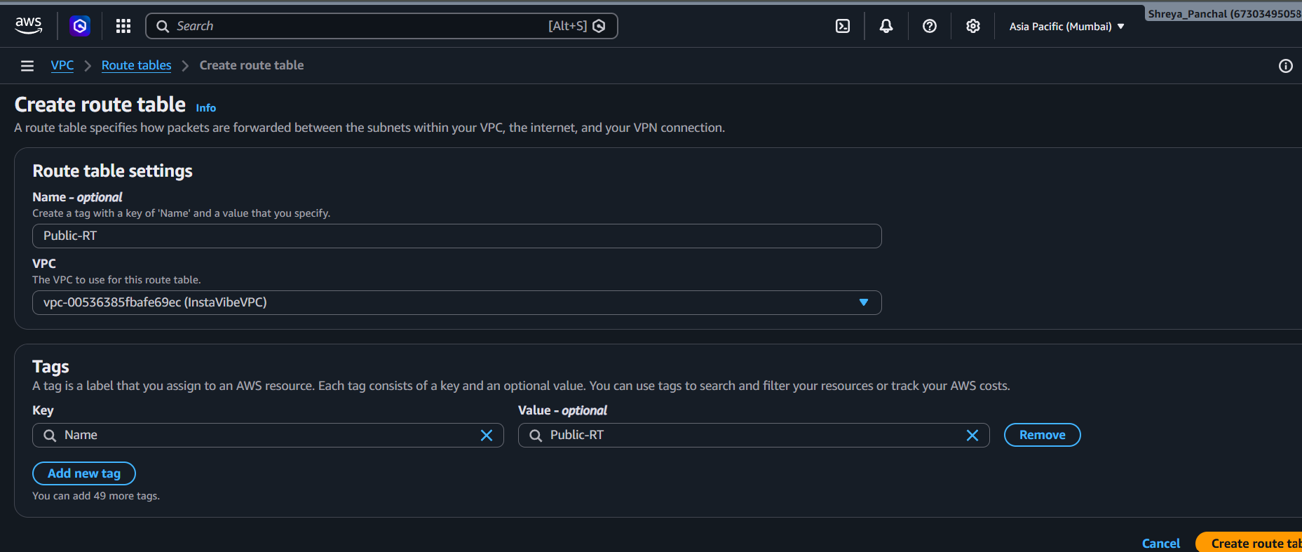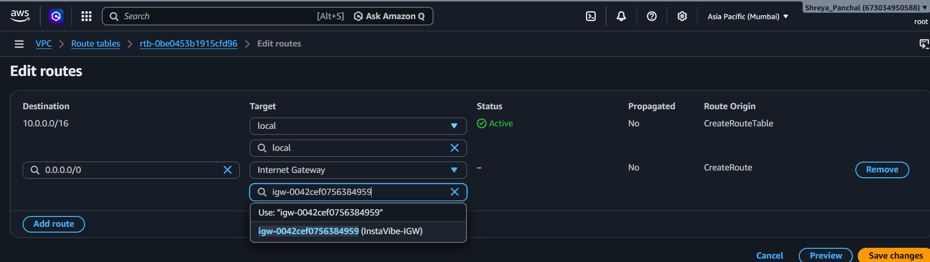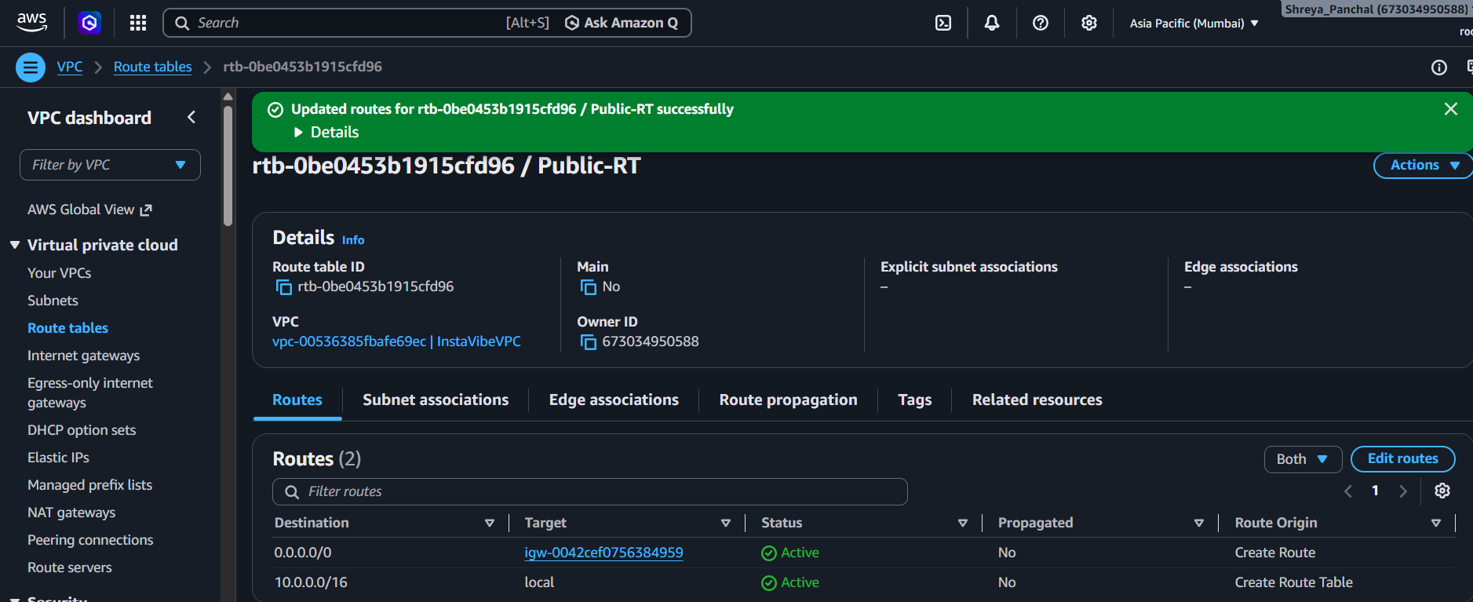
5. Draw a simple diagram (hand-drawn or using any online tool) showing your VPC, public subnet, private subnet, and Internet Gateway, and briefly explain in 3-4 lines how this setup is similar to how apps like Zomato separate their public user interface from their private databases.
Answer:
- Created a network diagram showing InstaVibeVPC, Public Subnet, Private Subnet, and Internet Gateway.
- The PublicSubnet-Zomato hosts the web server and can access the internet through the Internet Gateway.
- The PrivateSubnet-Zomato contains backend services or databases and has no direct internet access.
- This architecture improves security by separating public-facing resources from private backend resources.
Result:
The VPC architecture successfully separates the public web layer from the private backend layer, similar to how applications like Zomato securely host their services.
Diagram:
+------------------------------------------------------+
| InstaVibeVPC (10.0.0.0/16) |
| |
| +------------------+ +------------------------+ |
| | Public Subnet | | Private Subnet | |
| | 10.0.1.0/24 | | 10.0.2.0/24 | |
| | EC2 Web Server | | Database / Backend | |
| +------------------+ +------------------------+ |
+-------------------------▲----------------------------+
│
+--------------------+
| Internet Gateway |
+--------------------+
│
🌐 Internet
